**Project Design Phase-I**

**Technology Stack (Architecture & Stack)**

|  |  |
| --- | --- |
| **Date** | **03 October 2022** |
| **Team ID** | **PNT2022TMID52758** |
| **Project Name** | **Industry Specific Intelligent Fire Management System** |
| **Maximum Marks** | **4 marks** |

**Technical Architecture**

The architectural diagram of the model is as below and the Technology used is shown in table1 & table 2

**Industry Specific Intelligent Fire Management System**

**References:** [**https://www.britsafe.in/publications-and-blogs/safety-management-magazine/safety-management-magazine/2021/intelligent-fire-alarm-systems-for-new-age-smart-buildings/**](https://www.britsafe.in/publications-and-blogs/safety-management-magazine/safety-management-magazine/2021/intelligent-fire-alarm-systems-for-new-age-smart-buildings/)

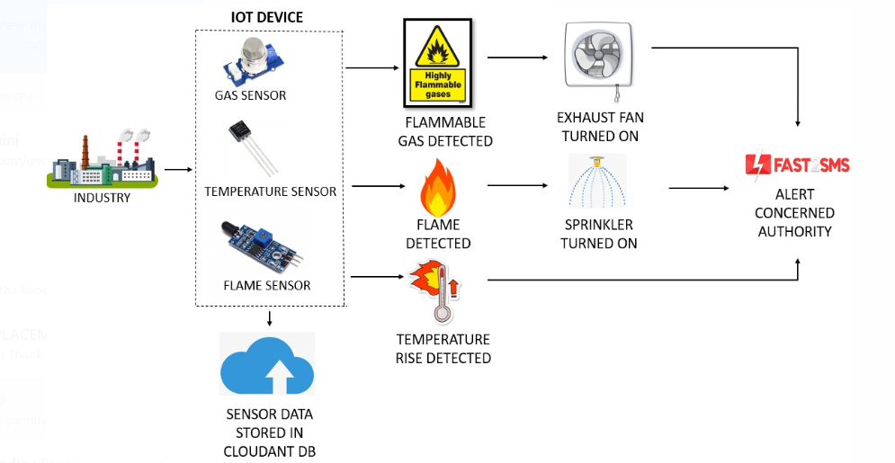

**Table -1: Components and Technologies**

|  |  |  |  |
| --- | --- | --- | --- |
| **S.No** | **Component** | **Description** | **Technology** |
|  | User Interface | How user interacts with application  ( Web UI ) | HTML, CSS, JavaScript |
|  | Application Logic-1 | Logic for a process in the application | Python |
|  | Application Logic-2 | Logic for a process in the application | IBM Watson IoT Platform |
| 4. | Database | Data Type, Configurations etc. | MySQL |
| 5. | Cloud Database | Database Service on Cloud | IBM Cloudant |
| 6. | File Storage | File storage requirements | IBM Block Storage |
| 7. | External API-1 | Purpose of External API used in the application | REST API |
| 8. | Infrastructure (Server / Cloud) | Application Deployment on Local System / Cloud | Local, Cloud Foundry. |

**Table-2: Application Characteristics:**

| **S.No** | **Characteristics** | **Description** | **Technology** |
| --- | --- | --- | --- |
|  | Open-Source Frameworks | List the open-source frameworks used | Node.js, Web UI |
|  | Security Implementations | List all the security / access controls implemented, use of firewalls etc. | Encryptions, IAM Controls |
|  | Scalable Architecture | Justify the scalability of architecture | Three tier(data, Application and Presentation) |

**References:**

[**https://www.ibm.com/cloud/architecture**](https://www.ibm.com/cloud/architecture)

[**https://nodered.org/**](https://nodered.org/)